FICO Analytic Challenge Midpoint Report - Group One

Marcus Jackson
Bowie State University
FICO Educational Analytics Challenge
Dr.Latson
November 9, 2024

FICO Analytic Challenge Midpoint Report
The PocketWatchers, a group of junior and senior Computer Technology majors from Bowie State University, are actively engaging in the FICO Educational Analytics Challenge to create an AI model for identifying fraudulent credit card transactions. The challenge seeks to address the issue of fraudsters adopting advanced tactics to replicate legitimate transactions, rendering them nearly indistinguishable from actual activity. Advanced behavioral analytics are utilized to detect abnormalities and patterns suggestive of fraudulent conduct, hence protecting financial integrity. The team is developing a robust and effective data detection model using cutting-edge machine learning technology such as neural networks. The team is reviewing and preprocessing a large dataset to extract the most useful and important attributes, and the model is being actively trained and optimized to attain optimal performance.
The AI model's preliminary findings have exceeded early expectations in terms of efficiently detecting fraudulent transactions, indicating substantial potential for reducing financial losses and strengthening overall security measures. The team has rigorously studied the available data, created a complete collection of insightful features, and is now using modern data modeling techniques to train and assess the usefulness of these features.

Data Analysis
A thorough investigation of cardholder spending patterns, time, and geographic regions was carried out. Several repeating fraud patterns were found, including continuous transactions made in different countries within a short period of time, generally late at night or early in the morning. Temporal anomalies, Card Presence Discrepancies, and foreign transaction susceptibility were among the key features used to distinguish between fraudulent and genuine transactions. Temporal anomalies revealed that fraudulent transactions were more likely to occur late at night or early in the morning. Card Presence Discrepancies were frequently linked to Card Not Present (CNP) transactions, in which the physical presence of the card was not necessary. Transactions conducted outside of the cardholder's country of residency were shown to be more likely to be detected as fraudulent.

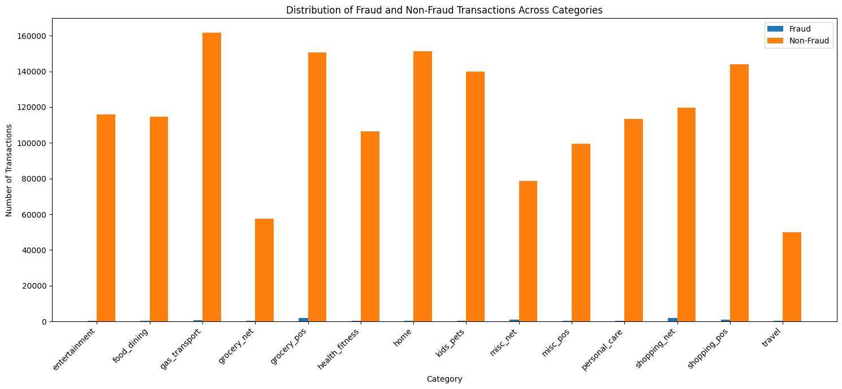
Distribution of Fraud and Non-Fraud Transactions Across Categories

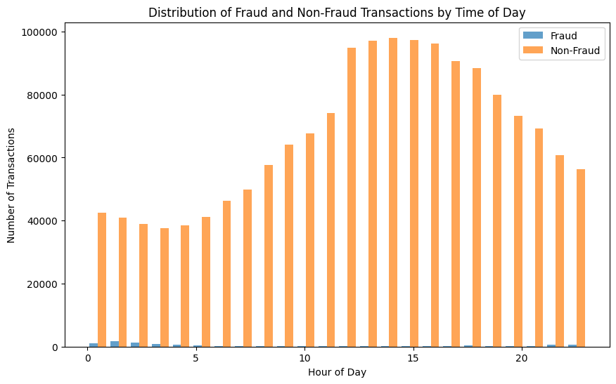
Distribution of Fraud and Non-Fraud Transactions by the Time of Day
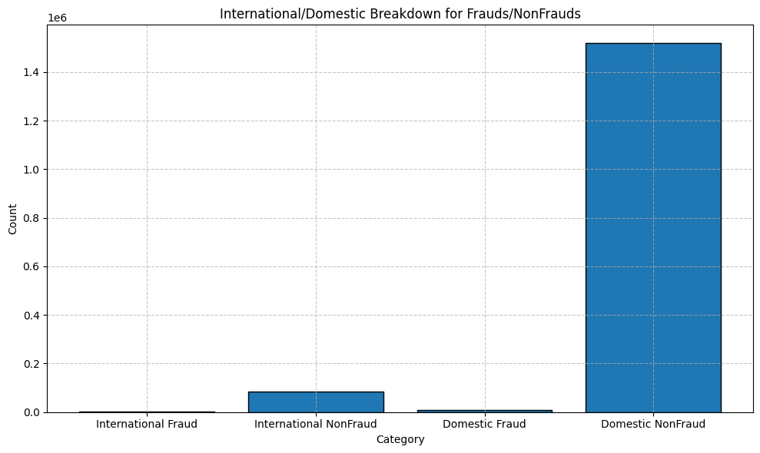
International/ Domestic Breakdown for Frauds/Non-Frauds

Fraud Rates Across Sub Populations
The fraud rates for CNP (Card Not Present) and CP (Card Present) transactions are as follows: The fraud rate is higher in the CNP population, accounting for 35.82% of all frauds. For domestic and cross-border transactions, international fraud rates are higher than domestic ones, accounting for 7.76% of total frauds.

Feature Engineering
The team created a thorough set of characteristics to detect anomalous spending trends in POS transactions. The key data columns were transaction type, transaction amount, transaction date and time, merchant nation, merchant state, cardholder country, and cardholder state. The team observed the time between cardholder transactions, assessed transaction volume, and kept an eye on low-value purchases. This method ensured the accuracy and dependability of the fraud detection model. The researchers also used the merchant's latitude and longitude information to precisely calculate the geographic distance between consecutive transactions. These features were critical for distinguishing fraudulent from lawful transactions while adhering to ethical norms. Additional elements such as "IsSpent," "IsTransaction," and "transactionHour_Risk" were added to improve the prediction capabilities. The model also set minimum and maximum transaction amounts within each transaction category and identified transactions that deviated considerably from predefined criteria. A specialized component was added to detect the precise hours of the day with the highest frequency of fraudulent activity, allowing the model to proactively analyze and reduce related risks.

Logistic Regression Model
After thoroughly analyzing the transaction data to identify discernible patterns, trends, and significant correlations, while also mitigating the potential impact of inherent biases, the team meticulously engineered a comprehensive set of features specifically designed to detect anomalous activities that may indicate fraudulent behavior. As previously stated, these features include a wide range of characteristics, such as temporal patterns (e.g., time intervals between transactions, purchase volume within specific timeframes), location-based features (e.g., geographical distance between consecutive purchases), and transaction amount-related features (e.g., deviations from average and median spending patterns). The logistic regression model, known for its ability to predict binary outcomes, was carefully chosen as the principal classification strategy for this assignment. This robust model uses a linear combination of painstakingly built input characteristics, which are then converted using the logistic function. This clever mathematical transformation allows the model to determine the likelihood of a specific event, such as a valid or fraudulent transaction. The logistic regression model's intrinsic interpretability gives useful insights into the relative relevance of each variable in the decision-making process, allowing for a more in-depth knowledge of the underlying elements that contribute to fraudulent conduct.
The model demonstrated decent performance. During the forward selection process, it initially scored below 0.9 but then increased above 0.9 and stabilized. The AUC value for the test data was 0.964, slightly outperforming the train data, which had an AUC of 0.962. During the backward elimination process, the model achieved an AUC of 0.956. Although there was a slight decrease in performance, it remained above 0.9 and relatively stable. Overall, the model performed well for the first time. Selection methods have been invaluable, helping identify strong features and discard weaker ones. However, a feature not performing well initially doesn't mean it can't be improved. The team expects the model to become more accurate and reliable with ongoing analysis and adjustments.

Conclusion
As the FICO Analytic Challenge proceeds, the PocketWatchers team is dedicated to continuously refining and improving the existing fraud detection model. This constant pursuit of excellence will entail meticulously refining current features, investigating fresh techniques to feature engineering, and using the power of continuous data analysis to discover unique and insightful features. The team is excited to explore sophisticated analytical approaches and gain in-depth expertise in relevant areas such as anomaly detection, deep learning, and the ethical implications of deploying AI-powered fraud detection systems. The team is certain that by fostering a culture of continuous learning and innovation, they can greatly contribute to the development of cutting-edge fraud detection technologies that successfully defend the financial interests of consumers and institutions alike.

My Contribution to the group
Throughout this hard endeavor, I actively participated in a number of critical initiatives. I spent numerous hours working with our distinguished mentors to ensure that our team's approach was consistent with best practices and that we were making steady progress. But we are not flawless, and we slipped behind, so I worked with mentors to get back on track. I helped design numerous essential features, such as 'IsSpent,' 'IsTransaction,' and 'CNP_High,' which were useful in detecting and curbing fraudulent behavior. Recognizing the value of cooperation, I took the effort to actively connect with other team members, building a cohesive and productive working atmosphere while also assuring seamless integration of our respective contributions. Furthermore, I took on the role of a leader, offering advice and assistance to my fellow team members, fostering a positive and collaborative team dynamic.

